DevOps Essentials Handbook

By:

Kritish Dhungel

Software Engineer

Copyright Notice:

© Kritish Dhungel, 2024. All rights reserved.

Disclaimer:

This handbook is intended for educational purposes only and are provided free of charge. No individual or entity is permitted to charge any amount of money for access to this content. If you have any questions or concerns regarding these notes, please feel free to contact me directly at i.kritish.dhungel@gmail.com.

Terms of Use:

By accessing and using these study notes, you agree to abide by the following terms:

1. You may freely view, download, and distribute these handbooks for personal, non-commercial use only.

2. You may not modify or alter the content of this handbook without explicit permission from the author.

3. You may not sell, reproduce, or distribute these notes for commercial purposes without prior written consent.

Author Contact Details:

Name: Kritish Dhungel

Email: [i.kritish.dhungel@gmail.com](mailto:i.kritish.dhungel@gmail.com) / [kritishdhungel@gmail.com](mailto:kritishdhungel@gmail.com)

Phone: +977-9851240433 (Viber / WhatsApp available)

# Getting the Most Out of This Ultimate DevOps Essentials Handbook

1. Regular Updates: This handbook will be uploaded regularly, but not all at once. This approach allows for a steady and focused learning experience, giving you time to digest each chapter thoroughly before moving on to the next.

2. View as Your Study Buddy: Treat this content as your study companion. Take your time to read and understand each chapter, and don't hesitate to revisit previous sections as needed. Use these notes to reinforce your learning and deepen your understanding of DevOps concepts.

3. Practice Makes Perfect: I encourage you to actively engage with the material presented in these notes. Apply what you've learned in practical exercises, experiment with DevOps tools and techniques, and seek opportunities to implement DevOps principles in real-world scenarios. The more you practice, the more confident and proficient you'll become in DevOps practices.

By approaching this handbook with dedication and a proactive mindset, you'll be well-equipped to embark on your journey towards mastering DevOps principles and advancing your career in the field.

Contents

Getting the Most Out of This Ultimate DevOps Essentials Handbook 3

Introduction 5

Pre-Requisites of DevOps 6

Why Organizations Need DevOps: A Scenario Example 7

Standard Procedure to Create a Software 8

The Waterfall Model: A Beginner's Guide 10

Understanding Agile Development: A Beginner's Overview 11

Successor to Agile: DevOps 12

Evolution of DevOps: From Two Teams to One 13

The Birth of DevOps: 13

Key Principles of DevOps: 14

Stages of DevOps: 14

Introduction to DevOps Methodology: 16

Linux 18

# Introduction

Welcome to the DevOps Essentials Handbook—a comprehensive guide designed to equip you with the fundamental knowledge and practical skills needed to thrive in the dynamic field of DevOps. Authored by Kritish Dhungel, this handbook is crafted with a singular focus: to demystify DevOps concepts and empower aspiring professionals like you to embark on a successful DevOps journey.

In today's rapidly evolving technology landscape, DevOps has emerged as a critical methodology for streamlining software development, accelerating deployment cycles, and fostering collaboration between development and operations teams. Whether you're a seasoned IT professional looking to upskill or a newcomer eager to explore the world of DevOps, this handbook is tailored to meet your learning needs.

Within these pages, you'll discover a wealth of essential topics, including:

- The core principles and philosophy of DevOps

- Key tools and technologies used in DevOps environments

- Best practices for implementing DevOps processes and workflows

- Strategies for fostering a culture of continuous integration and continuous delivery (CI/CD)

- Practical tips and insights from industry experts to help you navigate real-world challenges

By leveraging the insights and resources provided in this handbook, you'll gain a solid understanding of DevOps fundamentals and acquire the confidence to apply these principles in your own professional endeavors. Whether you're aiming to advance your career, enhance your technical skills, or drive organizational transformation, the DevOps Essentials Handbook serves as your indispensable companion on the path to success.

Get ready to embark on an enriching learning journey and unlock the full potential of DevOps!

# Pre-Requisites of DevOps

Before diving into DevOps, it's essential to understand the prerequisites—foundational knowledge and skills that form the building blocks for successful DevOps implementation. Here are some key pre-requisites:

1. Understanding of Software Development: Familiarize yourself with software development processes, including coding, testing, and deployment. Basic knowledge of programming languages and version control systems (e.g., Git) is beneficial.

2. Knowledge of IT Operations: Gain insight into IT infrastructure, networking, and system administration. Understanding concepts like servers, databases, and virtualization will provide a solid foundation for DevOps practices.

3. Communication and Collaboration Skills: DevOps emphasizes collaboration between development and operations teams. Effective communication, teamwork, and problem-solving abilities are crucial for successful collaboration.

4. Automation Skills: DevOps relies heavily on automation to streamline workflows and reduce manual effort. Learn automation tools like Jenkins, Ansible, or Puppet to automate repetitive tasks and improve efficiency.

5. Continuous Learning Mindset: DevOps is a continuous journey of improvement and learning. Stay curious, open to new ideas, and committed to ongoing skill development to keep pace with evolving technologies and practices.

# Why Organizations Need DevOps: A Scenario Example

Imagine a software development company, XYZ Software, that is experiencing frequent delays and disruptions in its development and deployment processes. Despite having talented developers and a robust infrastructure, the company struggles to deliver new features and updates to its customers in a timely manner.

Here's why XYZ Software needs DevOps:

1. Faster Time to Market: With DevOps practices in place, XYZ Software can automate manual processes, streamline workflows, and accelerate the delivery of software updates. By reducing the time taken to develop, test, and deploy new features, the company can respond quickly to customer demands and stay ahead of competitors.

2. Improved Collaboration: DevOps fosters collaboration and communication between development and operations teams. By breaking down silos and promoting cross-functional teamwork, XYZ Software can align its development efforts with operational goals, leading to smoother deployments and higher-quality software releases.

3. Enhanced Stability and Reliability: DevOps emphasizes the use of automation, continuous integration, and continuous deployment (CI/CD) pipelines to standardize and automate development and deployment processes. By implementing robust testing practices and infrastructure as code (IaC), XYZ Software can ensure greater stability and reliability of its software systems.

4. Increased Efficiency and Cost Savings: By automating manual tasks and optimizing resource utilization, DevOps enables XYZ Software to operate more efficiently and cost-effectively. By reducing manual errors, minimizing downtime, and maximizing resource utilization, the company can achieve significant cost savings and improve its bottom line.

In summary, DevOps is essential for organizations like XYZ Software to overcome challenges, streamline processes, and achieve greater agility, efficiency, and competitiveness in today's fast-paced digital landscape.

# Standard Procedure to Create a Software

The Software Development Life Cycle (SDLC) is a structured process used by software development teams to design, develop, test, deploy, and maintain software applications. Here's an overview of the standard phases of the SDLC:

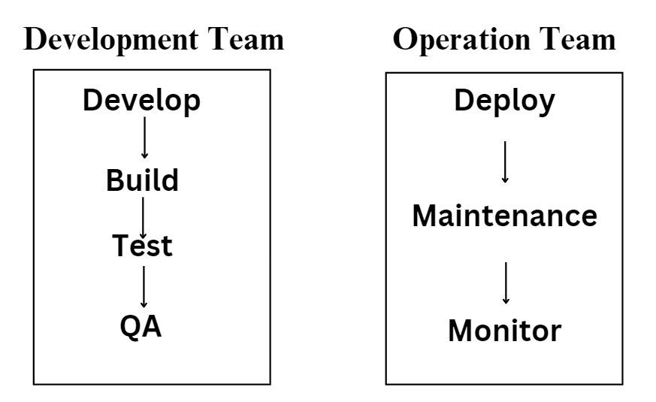

1. **Planning**: In this initial phase, project stakeholders define the project scope, objectives, and requirements. This involves gathering user requirements, assessing project feasibility, and creating a project plan that outlines timelines, resources, and deliverables.

2. **Analysis**: During the analysis phase, the project team conducts a detailed analysis of the requirements gathered in the planning phase. This involves breaking down user requirements into functional specifications and defining the system architecture and design.

3. **Design**: In the design phase, the system architecture and design specifications are translated into a detailed technical design. This includes designing the software's user interface, database structure, and application logic.

4. **Development**: The development phase involves coding and programming the software based on the design specifications. Developers write code using programming languages and development frameworks, following coding standards and best practices.

5. **Testing**: Once the development is complete, the software undergoes rigorous testing to identify and fix defects or bugs. Testing includes unit testing (testing individual components), integration testing (testing interactions between components), and system testing (testing the entire system).

6. **Quality Assurance (QA)**: In the QA phase, the software is evaluated against predefined quality criteria to ensure it meets user expectations and business requirements. QA engineers perform functional testing, performance testing, security testing, and usability testing to validate the software's quality and reliability.

7. **Deployment**: After successful testing and QA, the software is deployed to production environments for end-users to access and use. Deployment involves installing the software on servers, configuring settings, and ensuring compatibility with existing systems.

8. **Maintenance and Employee Training**: Once the software is deployed, it enters the maintenance phase. This involves providing ongoing support, fixing bugs, and releasing updates and patches as needed. Additionally, employee training may be conducted to familiarize users with the new software and its features.

9. **Monitoring**: Throughout the SDLC, the software is continuously monitored to ensure optimal performance, reliability, and security. Monitoring involves tracking system metrics, analyzing user feedback, and proactively addressing any issues that arise.

By following the standard phases of the SDLC, software development teams can systematically plan, develop, and deliver high-quality software applications that meet user needs and business objectives.

Well in short and simple language, the Software Development Life Cycle (SDLC) is like a roadmap that guides developers through the process of creating a software application. Here's how it works:

1. **Planning**: First, developers figure out what the software needs to do and how it should look. They talk to users and make a plan for how to build it.

2. **Analysis**: Next, they dive deeper into the details. They break down the plan into smaller tasks and figure out exactly what the software needs to do.

3. **Design**: Once they know what the software needs to do, they start designing how it will look and work. This is like creating a blueprint before building a house.

4. **Development**: Now it's time to start building the software! Developers write the code that makes the software do what it's supposed to do.

5. **Testing**: After the software is built, it's tested to make sure it works correctly. This is like checking a car to make sure it runs smoothly before driving it.

6. **Quality Assurance (QA)**: In this step, the software is checked again to make sure it's high-quality and meets all the requirements. It's like double-checking your work to make sure you didn't miss anything.

7. **Deployment**: Once the software is tested and approved, it's ready to be used by people. It's like opening a new store for business after everything is set up.

8. **Maintenance and Employee Training**: After the software is deployed, it needs to be taken care of and updated regularly. Sometimes, employees also need training to learn how to use the new software.

9. **Monitoring**: Throughout the whole process, the software is watched closely to make sure it's working well and to fix any problems that come up.

By following the SDLC, developers can build software step-by-step, making sure it works correctly and meets the needs of users. It's like following a recipe to bake a cake—each step is important to get the final product just right!

## The Waterfall Model: A Beginner's Guide

The Waterfall model is one of the oldest and most traditional approaches to software development. It's like following a step-by-step recipe—each phase of development flows downwards, like a waterfall, with no going back once you've moved to the next phase. Here's how it works:

1. **Requirements**: In the first phase, developers gather all the requirements for the software—what it needs to do, how it should look, and how it will be used.

2. **Design**: Next, they design the software based on the requirements. This is like creating a blueprint for a house before building it.

3. **Implementation**: Once the design is complete, developers start building the software. They write the code and put everything together.

4. **Testing**: After the software is built, it's tested to make sure it works correctly. This is like checking a car to make sure it runs smoothly before driving it.

5. **Deployment**: Finally, the software is deployed and made available to users. It's like opening a new store for business after everything is set up.

Problems with the Waterfall Model:

While the Waterfall model was widely used in the past, it has some significant drawbacks:

1. **Rigidity**: Once you move to the next phase, it's difficult to go back and make changes. This can be a problem if requirements change or if issues are discovered later in the process.

2. **Limited Customer Involvement**: Customers only see the final product at the end of the process, which can lead to misunderstandings or dissatisfaction if their expectations aren't met.

3. **Long Development Time**: Because everything is done sequentially, the Waterfall model can result in long development cycles, delaying the delivery of the final product.

## Understanding Agile Development: A Beginner's Overview

To address these issues, the Agile model was developed as a successor to the Waterfall model. Agile is like making a series of small, incremental improvements to the software, rather than trying to do everything at once. We'll explore Agile in more detail in further chapters, where we'll discuss its principles and how it differs from the Waterfall model.

Agile is a modern software development approach that emphasizes flexibility, collaboration, and continuous improvement. Unlike the Waterfall model, which follows a linear, step-by-step process, Agile is iterative and adaptive, allowing teams to respond to change and deliver value incrementally.

Here's how Agile works:

1. **Iterative Development**: Agile projects are divided into small, manageable iterations called sprints. Each sprint typically lasts 1-4 weeks and focuses on delivering a specific set of features or functionality.

2. **Cross-Functional Teams**: Agile teams are cross-functional, meaning they include members with diverse skills and expertise (e.g., developers, testers, designers). This encourages collaboration and allows teams to work together efficiently.

3. **Customer Collaboration**: Agile prioritizes customer collaboration and feedback. Customers are involved throughout the development process, providing input on requirements, reviewing work-in-progress, and providing feedback on completed features.

4. **Continuous Delivery**: Agile teams aim to deliver working software at the end of each iteration. This allows stakeholders to see tangible progress and provides opportunities for early validation and course correction.

5. **Adaptive Planning**: Agile embraces change and uncertainty. Plans are flexible and adaptive, allowing teams to adjust priorities, requirements, and strategies based on feedback and evolving needs.

## Successor to Agile: DevOps

While Agile revolutionized software development by promoting collaboration, flexibility, and customer focus, it's not the end of the story. DevOps emerged as the natural successor to Agile, extending the principles of Agile beyond development to encompass the entire software delivery lifecycle, including operations and deployment.

DevOps emphasizes collaboration between development and operations teams, automation of manual processes, and a culture of continuous improvement and learning. By breaking down silos and integrating development, testing, deployment, and operations into a seamless, automated workflow, DevOps enables organizations to deliver high-quality software faster, more reliably, and with greater efficiency.

In summary, while Agile focuses on iterative development and customer collaboration, DevOps extends these principles to encompass the entire software delivery lifecycle, making it the natural successor to Agile in today's fast-paced, continuously evolving software development landscape.

# Evolution of DevOps: From Two Teams to One

In traditional software development processes, there were often two distinct teams responsible for different stages of the software delivery lifecycle:

1. Development Team:

- Developed new features or software applications.

- Built the software, converting source code into executable programs.

- Conducted testing to ensure the quality and functionality of the software.

- Passed the tested code to the Quality Assurance (QA) team for further validation.

2. Operations Team:

- Deployed the software to production environments.

- Managed maintenance tasks, such as updates, patches, and bug fixes.

- Monitored the performance and availability of the deployed software.

While these teams operated independently, their goals were ultimately aligned: to deliver high-quality software that meets the needs of end-users.

## The Birth of DevOps:

Recognizing the challenges and inefficiencies of siloed development and operations processes, the DevOps movement emerged. DevOps advocates for breaking down the barriers between development and operations teams and fostering collaboration and communication across the entire software delivery lifecycle.

By integrating development, deployment, maintenance, and monitoring activities into a unified and continuous process, DevOps aims to:

- Accelerate the delivery of new features and updates.

- Improve software quality and reliability.

- Enhance collaboration and communication between teams.

- Increase efficiency and productivity.

## Key Principles of DevOps:

DevOps is guided by several core principles, including:

1. Automation: Automate repetitive tasks to streamline processes and reduce manual errors.

2. Collaboration: Foster a culture of collaboration and shared responsibility between development and operations teams.

3. Continuous Integration and Deployment: Implement continuous integration and continuous deployment (CI/CD) pipelines to deliver changes rapidly and reliably.

4. Monitoring and Feedback: Monitor application performance and user feedback to drive continuous improvement and optimization.

By embracing these principles and adopting DevOps practices and tools, organizations can transform their software delivery processes and achieve greater agility, efficiency, and innovation.

## Stages of DevOps:

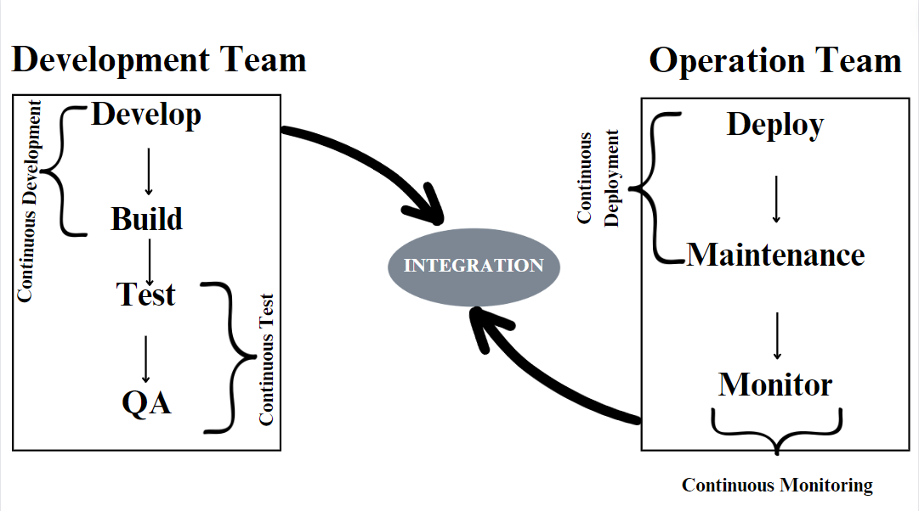

Stage 1: Version Control

1. Purpose: Maintain different versions of code and track changes over time.

2. Activities:

- Use version control systems like GIT to manage source code repositories.

3. Key Tool:

- GIT: A distributed version control system widely used for tracking changes in codebases.

Stage 2: Continuous Integration

1. Purpose: Automate the process of integrating code changes from multiple developers into a shared repository.

2. Activities:

- Compile code, validate syntax, conduct code reviews, and perform unit testing.

3. Key Tools:

- Jenkins: A popular open-source automation server for continuous integration and continuous delivery pipelines.

- Other renowned tools: Travis CI, CircleCI, GitLab CI/CD.

Stage 3: Continuous Delivery

1. Purpose: Automate the deployment of applications to testing environments.

2. Activities:

- Build application artifacts using tools like Maven.

- Deploy built applications to test servers for validation and testing.

3. Key Tools:

- Maven: A build automation tool used primarily for Java projects.

- Other tools: Gradle, Apache Ant.

Stage 4: Continuous Deployment

1. Purpose: Automate the deployment of applications to production environments.

2. Activities:

- Automatically deploy tested and validated applications to production servers for release.

3. Key Tools:

- Configuration Management Tools: Chef, Ansible, Puppet.

- Containerization and Orchestration: Docker, Kubernetes.

Stage 5: Continuous Monitoring (Optional)

1. Purpose: Monitor the performance, availability, and health of deployed applications and infrastructure.

2. Activities:

- Collect and analyze metrics, logs, and events to detect and respond to issues proactively.

3. Key Tools:

- Monitoring and Logging Solutions: Prometheus, Grafana, ELK Stack (Elasticsearch, Logstash, Kibana).

- Application Performance Monitoring (APM) Tools: New Relic, AppDynamics.

# Introduction to DevOps Methodology:

Before diving into the specific stages and practices of DevOps, it's essential to understand the fundamental principles and objectives that underpin this methodology. DevOps represents a paradigm shift in software development and delivery, emphasizing collaboration, automation, and continuous improvement across the entire application lifecycle.

In this section, we'll explore the essence of DevOps, its primary objectives, and its role in fostering the rapid development of high-quality software. By embracing DevOps principles and practices, organizations can streamline their development processes, accelerate delivery timelines, and enhance overall software reliability and quality.

Let's delve into the core principles of DevOps and discover how they can transform your approach to software development and operations.

1. DevOps as a Methodology:

- This statement nicely summarizes the essence of DevOps by highlighting its role in managing the entire application development lifecycle. It aligns well with the overview of DevOps and its evolution from siloed teams to a unified approach.

2. Objective of DevOps:

- This point emphasizes one of the primary goals of DevOps, which is to shorten the software development lifecycle (SDLC). It complements the section on the benefits of DevOps, showcasing its impact on accelerating delivery timelines.

3. DevOps for Superior Quality Code:

- This resource underscores the importance of DevOps in facilitating the rapid development of high-quality code. It reinforces the idea that DevOps is not just about speed but also about reliability and quality.

# Linux